**Application Development**

PRACTICAL: 17 Create web applications to generate report.

1.

Create Date Set

Connect (import) database

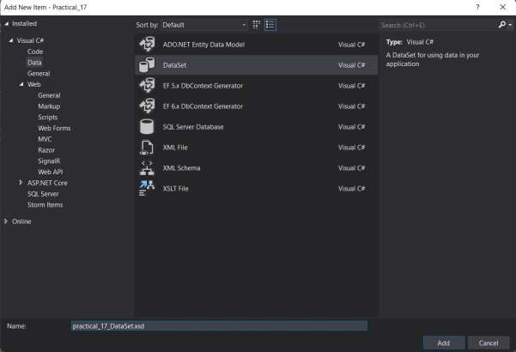

Click On Add Connection

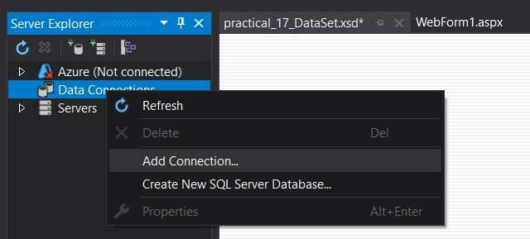

# Browse database file and then click ok

1 | P a g e **20012021028_Patel Jaydip K**

Open DataSet.xsd file and right click on it then click on Add the click on TableAdapter

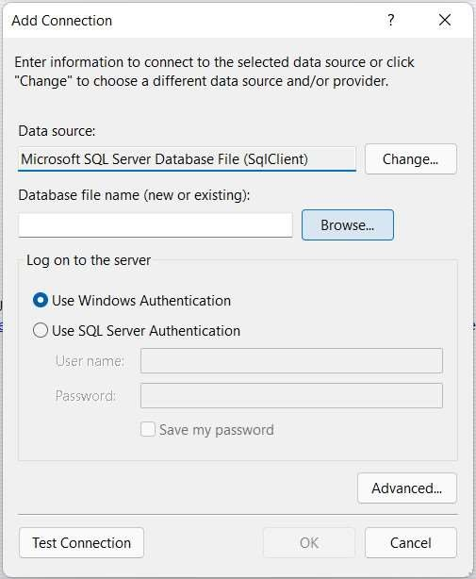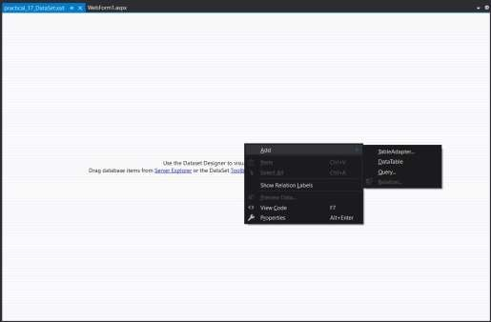

# Select your Database and Click Next

Then Click Next then select use SQL Statement the next

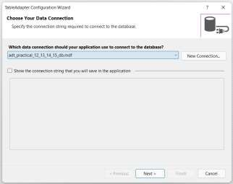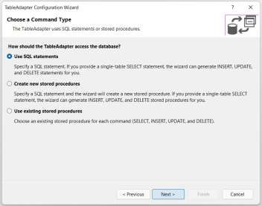

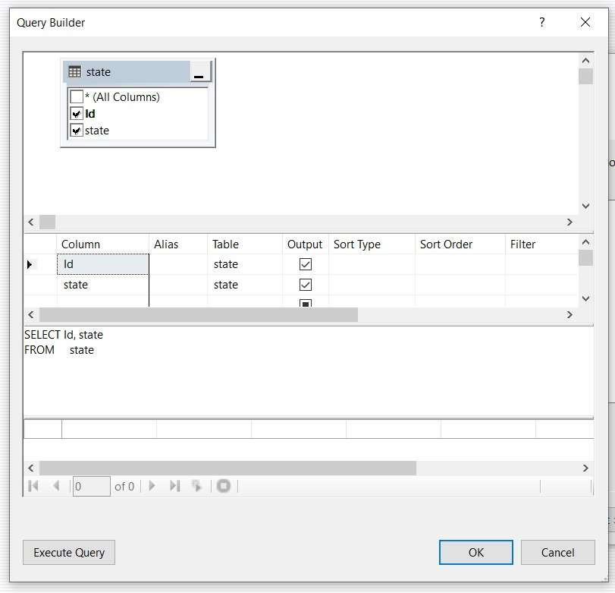

Then Add Report1.rdlc file

# Add WebForm in over Project In WebForm Add ScriptManager and ReportViewer from toolbox Then click on right side arrow key the choose your report

Then Run

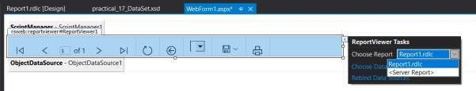

OUTPUT:

